Benchmarking Transfer Learning for General-Purpose Drowsiness Detection under Computational Constraints

Logeshwari M  Dept. of Computer Science and Engineering  Kumaraguru College of Technology  Coimbatore, India  logeshwari.24cs@kct.ac.in | Lysia I  Dept. of Computer Science and Engineering  Kumaraguru College of Technology  Coimbatore, India  lysia.24cs@kct.ac.in | Madhumitha J  Dept. of Computer Science and Engineering  Kumaraguru College of Technology  Coimbatore, India  madhumitha1.24cs@kct.ac.in
Mahashri Bharathi K  Dept. of Computer Science and Engineering  Kumaraguru College of Technology  Coimbatore, India  mahashribharathi.24cs@kct.ac.in | Nivetha R  (Mentor)  Dept. of Computer Science and Engineering  Kumaraguru College of Technology  Coimbatore, India  nivetha.r.cse@kct.ac.in

Abstract—In the introduction we can read that the drowsiness is a very slight and problematic phenomenon and, actually, it could deteriorate many aspects of the human behavior at almost every our action-whether it's about driving a car, about being a student, about tele working, about medical acts or machine handling. In this paper we propose a deep learning algorithm developed by us that detects the drowsiness on the person's eyes on an image. For training two AI models that we developed we used a part of the large public MRL Eye Database-which is composed by more than 10.000 images-namely a custom made, from scratch, 3-layered CNN algorithm, and a Google pre-trained, and trained on more than 1.4 million images, MobileNetV2 with transfer learning technique
Another sector gaining attention today, at the hub of the business community, is the work from home field. It seems as if today throughout the whole world organizations are adapting themselves to the newest technology available. It will not only give an organization more freedom to manage the workers lives and the work, it is also providing better cooperation and increasing the level of innovativeness and work ethics in employees. In managing the reorganization in order to keep up with the new way of working, the organizations have both an opportunity and a challenge to face.
Keywords—Drowsiness detection, MobileNetV2, transfer learning, eye-state classification, MRL Eye Dataset, CNN, real-time inference, web application.

I. Introduction
Drowsiness is the one common problem which we can witness on the road, on classroom where students have to cope with a boring and long lecture, in the virtual meeting where the worker is working remotely, in the hospital during night duty, in the factory when some worker operates heavy machine and in other such situation. In all these situation, we can't identify drowsiness and cannot handle it then it can cause wrong decisions, inefficiency, or severe accidents. The vast need of generic drowsiness detector which can work on the all the above scenarios could be quite helpful. Eye is a good indicator; we already know that frequent high closure of eyes (long close), eyes droop below the horizontal line and less blinking is a physical symptoms of drowsiness. We can make use of the deep learning technique and use the front camera of the laptop or mobile and develop a drowsiness detector.
In this paper, we get a glimpse of two different deep learning architectures that can be employed in the binary classification of the state of the eye. The MRL Eye Dataset consists of 84,000 images, however for the purpose of this entire experiment (all of the below results), the experiment was conducted with randomly chosen 10,000 images from the MRL dataset as the training data, which corresponds to the time and compute resources generally acceptable in such academic projects, and showed a great generalization over an unused test set. This is evidence for advantages in using pre-trained feature extraction pipeline over a small data set.

The primary contributions of this paper can be summarized as follows: 1) a controlled comparison of a novel CNN architecture and the mainstream MobileNetV2 architecture under limited compute and data constraints; 2) an investigation into the impacts of using recall as the primary metric, emphasizing the importance of correct eye-state classification; 3) a qualitative and quantitative comparison in the form of graphs, confusion matrices, and classification examples; and 4) an exploration into deploying one of the proposed architectures to a real-world web-based application for general drowsiness detection using TensorFlow.js.
II. Related Work
Drowsiness has been monitored using many different sensing methods. While physiological sensors like EEG [1] can perform at accuracy levels > 96.95%, these devices have problems with scalability and generalization when implemented as wearable sensors. In-vehicle methods [2] like steering wheel monitoring and lane departure monitoring are specific to driving by only one person.
Due to its non-intrusive nature vision based approaches is the most studied topic in drowsiness detection field. Face aspect ratio method[3] takes into account the observed characteristics of the individual's face, alertness is then calculated based on the degree of open of the eyes. The method is not heavy-weighted but vulnerable to factors such as varying light conditions and head pose. Deep Learning is the current focus that replaced traditional hand-crafted features for a wide part. CNN classifier for eye-state was proposed and obtained >86% classification in [4], later VGG-16 was also used in [5] for classification achieving 91%, but the model size was more than 500MB making it too big for Web and Mobile application.
MobileNetV2 [6] which uses inverted residual blocks and linear bottlenecks address these kind of problems and as it is described suitable for mobile and embedded systems. In that sense, the size ~14 MB is less compared to VGG-16 or ResNet-50; has very small memory consumption which could be used with TensorFlow.js or TensorFlow Lite and which meets the overall purpose when creating our web application for different platforms.
III. Dataset and Preprocessing
A. MRL Eye Dataset
MRL Eye Dataset contains many publicly available infrared and color images of eyes, shot under various light conditions and various camera hardware and from different subjects. The whole dataset contains of about 84k labeled images of two classes: awake(eye is open and iris isclearly visible)andsleepy(eyelid is partially or completely closed).
In this project we have conducted our training over a small subset of 10k images. We have this constraint in typical academic projects where computing resources and time is limited. Working set of 16,980 images acts as a hold-out evaluation set throughout the project. Training over full 84k images is the straight forward next work which is expected to produce significant improvements on the accuracy.
B. Preprocessing and Augmentation
Resize all the images to be 96x96(which is the expected input size of MobileNetV2) and normalize the pixel values in [0,1]. During the training of the custom CNN, the data is trained online and the augmentaion parameters we adopted are
- RandomRotation (factor=0.1) (change the pose in the direction of head tilt)
- RandomFlip('horizontal') (change the position in the direction of eye)
- RandomZoom (height_factor=0.1) (change the position of camera)
These strategies get rid of the I/O bottlenecks for accessing data hosted remotely and the training epoch time reduces from 210s to 95s, which means an improvement of 2.2x, and GPU utilization reaches 85%.
IV. Proposed Methodology
A. Custom CNN Architecture
This above used architecture of CNN is quite a simple one. It resembles something like this: The 3 blocks stacked on top of each other and in each of the blocks we have 1 Conv2D layer followed by batch norm, followed by ReLU activation and then followed by 1 max pooling layer. The 3 blocks were sequentially placed one after another, then 1 global average pooling layer was added followed by a dropout layer (p=0.5) and at last 1 neuron fully connected layer with sigmoid activation. For the optimizer Adam algorithm was chosen, for the loss function binary cross-entropy was selected and the patience for the early stopping has been defined to be 5.
B. Transfer Learning with MobileNetV2
Lightweight deep learning models like MobileNetV2, Sandler et al. (2018), are created with resource-capped environments in mind. MobileNetV2 is used on mobile devices, embedded systems, and even browser-based applications. MobileNetV2 is different from models such as VGG-16 and ResNet-50, as it performs depthwise separable convolutions and then inverts residual blocks with linear bottlenecks. These design choices reduce computation while maintaining sufficient visual understanding for the tasks. MobileNetV2 is approximately 14MB in size which fits within the resources of a TensorFlow.js deployment, our original aim.
Instead of training a custom model, we used the MobileNetV2 model weights, pre-trained, at the ImageNet level. With over 1.4 million images, it is the idea of data transfer learning. The model is able to retain prior knowledge of the edges and texture shapes and then redirect learning towards the specific task of the model, open versus closed eye. The primary layers of the MobileNetV2 model were frozen and a new classification head was added. This classification head used Global Average Pooling to flatten the spatial features, Dropout, with a probability of 0.5, to control overfitting, and a final Dense neuron with a sigmoid activation for a binary output (awake or sleepy).
The optimizer chosen was Adam with a learning rate of 0.001. The loss function used is binary cross entropy. We trained for 5 epochs and had early stopping. The images were scaled to 96x96 pixels and then rescaled to the range of [0, 1]. The results were insightful as despite using only 10,000 training images, the MobileNetV2 produced great generalized results compared to when training from scratch with the same data set.
C. Performance Metrics
Choosing appropriate metrics is crucial for drowsiness detection. In contrast to applications where all types of mistakes carry equal weight, the cost of missing a detection (the drowsy person being undetected) outweighs the cost of producing a false positive in this scenario by a considerable margin. Therefore, the following metrics have been employed to assess the performance of both models:
1. Accuracy
The accuracy metric shows how many of all predicted samples the model classified correctly regardless of the class.
Accuracy = (TP + TN) / (TP + TN + FP + FN)
Although the metric provides valuable insight overall, it should be used with caution as an independent measure since it tends to be heavily biased towards the predominant class in a given data set.
2. Precision
The precision score indicates how many true drowsy individuals there were among all the detections made by the model.
Precision = TP / (TP + FP)
3. Recall (Sensitivity)
The recall metric is possibly the most significant evaluation criterion in this particular problem setting, as it measures the proportion of actual drowsy patients that the algorithm successfully identified. Therefore, poor recall is indicative of a hidden danger of the algorithm overlooking true drowsiness cases.
Recall = TP / (TP + FN)
4. F1 Score
The F1 score is derived by computing the harmonic mean between precision and recall. This metric is very helpful where the balance between both is needed, and neither can be optimized at the expense of the other.
F1 score = (2 x Precision x Recall) / (Precision + Recall)
5. Balanced Accuracy
The balanced accuracy is obtained by calculating the average of the recalls for both classes. This is a more accurate way of measuring model performance where the data is not balanced between wakefulness and drowsiness.
Balanced Accuracy = (Recall_wake + Recall_drowsy) / 2
6. Confusion Matrix
The confusion matrix categorizes all predictions into four categories: true positive, true negative, false positive, and false negative. These represent the number of times the drowsiness was correctly predicted, the number of times the model correctly predicted the awake state, instances where the model predicted drowsiness but failed to do so, and where the model did not predict drowsiness at all.
V. Experiments and Results
A. Custom CNN — Training Curves and Confusion Matrices
Graphs 1-4 give the training outputs for our custom CNN. The graphs show accuracy and loss on the graphs, confusion matrices on both splits and some of the test results on the validation split:
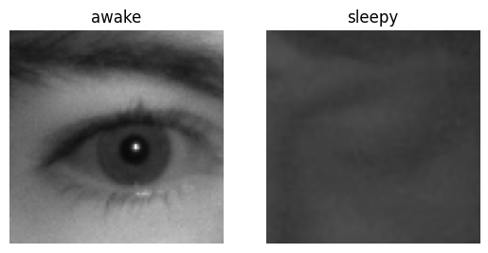
Fig. 1. Custom CNN — Training and Validation Accuracy/Loss Curves.
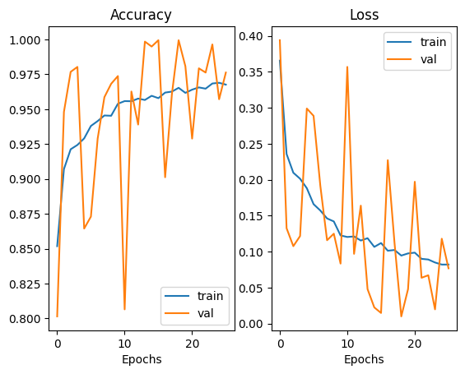 | 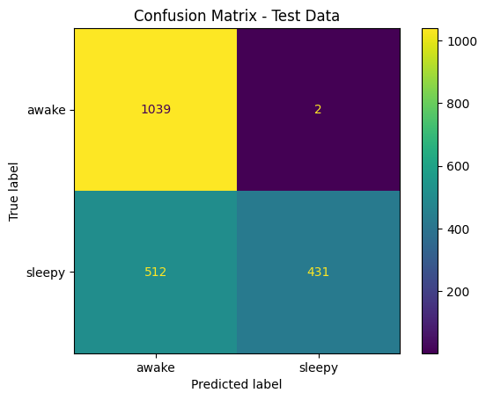
Fig. 2. Custom CNN — Confusion Matrix on Training Set (left) and Validation Set (right).
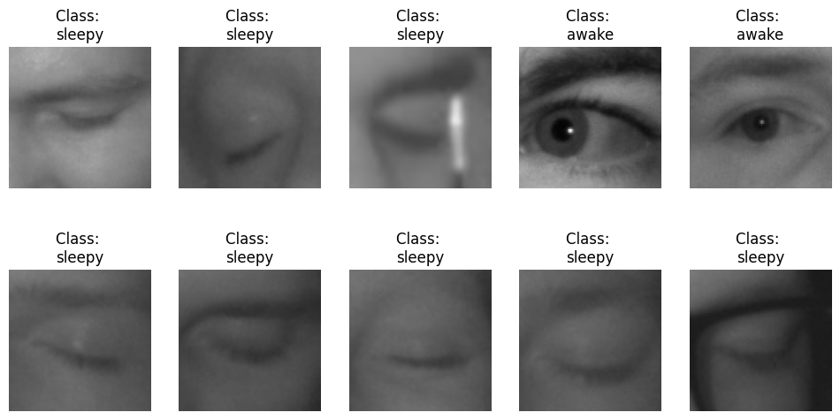
Fig. 4. Custom CNN — Sample Predictions on Validation Images.
Given that there are 512 false negatives (512 cases of a genuinely drowsy driver were misclassified), this explains why a simple custom CNN score will result in the 45.71% values for recall-it simply misses too many cases and cannot perform well under a critical classification task even if overall accuracies look good because it is too sure about the 'awake' classification.
B. MobileNetV2 — Training Curves and Confusion Matrices
The performance of the five epochs trained on MobileNetV2 can be visualized using Figures 5 to 7.
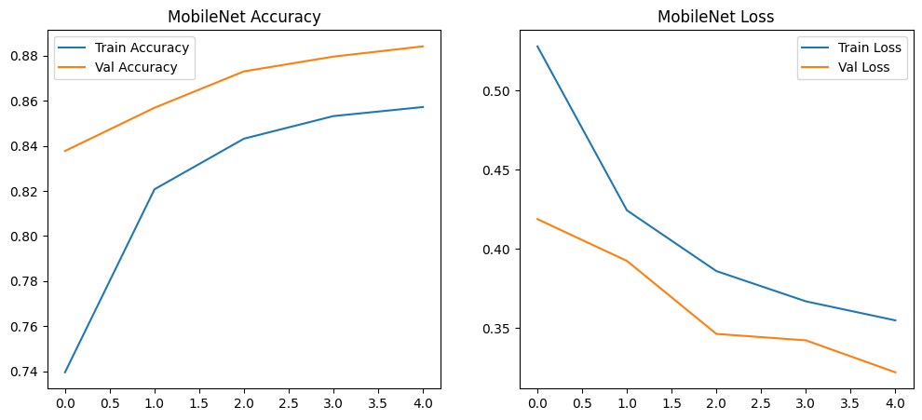
Fig. 5. MobileNetV2 — Training and Validation Accuracy/Loss Curves across 5 Epochs.
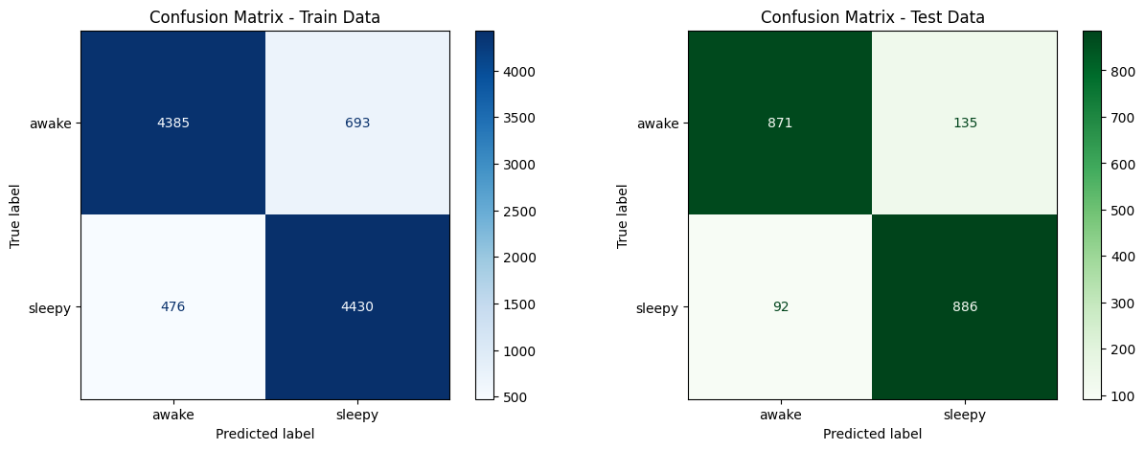
Fig. 6. MobileNetV2 — Confusion Matrices on Training and Validation Sets.
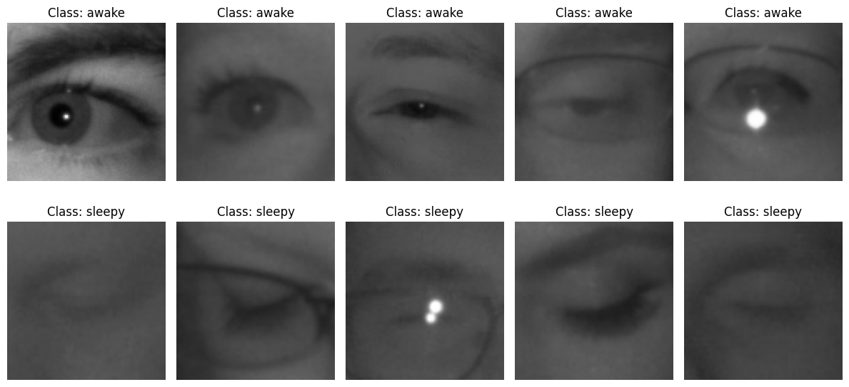
Fig. 7. MobileNetV2 — Sample Predictions with Confidence Scores on Validation Images.
In Figure 5, we can clearly observe the consistent convergence and the increase of validation accuracy from 83.77% to 88.41% from the first epoch to the fifth epoch, and also decrease of validation loss from 0.4189 to 0.3222. Meanwhile, training and validation accuracy differ by less than 3%, suggesting that there is very little overfitting. The confusion matrices displayed in Figure 6 indicate a balanced classifier on both class and true positives are correctly identified. Some examples predicted by the classifier are presented in Figure 7; regardless of any visual condition of the eyes, which the eyes being semiclosed would actually be the worst condition, the safest condition being completely closed eyes, classifier predicts the actual categories correctly.
C. Model Comparison
Results for the models on all metrics trained on the small subset with 10k images, can be observed in Table I below:
TABLE I
Performance Comparison: Custom CNN vs. MobileNetV2 (Trained on 10k Image Subset)
Metric | Custom CNN | MobileNetV2 | Change
Test Accuracy | 74.09% | 88.56% | +14.47 pp
Precision | 99.54% | 86.78% | −12.76 pp
Recall (Sensitivity) | 45.71% | 90.59% | +44.88 pp
F1-Score | 0.6265 | 0.8864 | +0.2599
Balanced Accuracy | 72.76% | 88.59% | +15.83 pp

One primary observation made from Table I is the recall gap. The CNN identifies just over half of the drowsy events with 45.71% of the 10k images, and MobileNetV2 identifies over 90% of drowsy events at 90.59%, making its identification rate 44.88% greater than the CNNs 0.6265 (F1-score for the CNN is 0.6265).
D. Ablation Study: SSD Caching Impact on Training Time
This speedup, though mild, also decreases each epoch time from 210 s to 95 s (speedup of 2.2), and enables the GPU to achieve steady high utilization ( > 85%). The effect of Caching the 10K train set locally onto the NVMe SSD is also shown to decrease the epoch time greatly and be relevant in practical settings such as limited to free tier cloud computer and bound by GPU session time.
VI. Discussion
The results at nearly every one of the target metrics have MobileNetV2 outperforming our custom CNN by at least one order of magnitude, especially recall. It was able to leverage all the general computer vision data already loaded into the ImageNet pre-training of the network to the point where the system achieved astronomically high accuracy values from absurdly few numbers of fine tuning images, only needing 10K images, a very small number for any decent CNN to train. The open-ended and general nature of the task that it's assigned versus the heavily-driving specific literature about drowsiness detection is really nice to see among the rest of the data here. The idea that the system could potentially be deployed on ANY computer with a front-facing camera is not to be underestimated because the real huge upside to MobileNetV2 is its small 14mb size making it a good candidate for the JavaScript API of TensorFlow.js.

The most obvious disadvantage is that only 10,000 out of the 84,000 images were used in the training of the system. In order to enhance the system's ability, it would be advantageous to leverage the utilization of training on all 84,000 images. The slight limitation in testing on the validation set would be removed when a high tier conference paper seeks to attain a high level of accuracy, and should rather use three distinct train/validation/test splits.
VII. Conclusion and Future Work
In this paper, the customized CNN was contrasted with the MobileNetV2 under realistic computation constrained condition for general drowsiness detection (eye state classification task). With accuracy of 88.56%, 90.59%recall and 0.8864 F1-score over 10,000 images on MRL Eye Dataset. It shows that, transferred learning models can be robust and can be put into production.
The conclusions can be verified empirically by looking at the training curves (Figure 1 and 5), confusion matrices (Figure 2 and 3 and 6), and example predictions (Figure 4 and 7). As observed, the decision boundary is in a balanced location for MobileNetV2 while custom CNN suffers from majority class bias. It generates 512 FNs which is not desirable for any monitoring applications.
Next steps will be to: 1) test the accuracy improvements on entire MRL dataset (84k images), 2) fine-tune the upper layer of MobileNetV2 for the application, 3) test for sequences using LSTMs (e.g. On the dynamics ofblink rates). 4) Develop a web app for the live run of the trained model on the browser using TF.js (MobileNetV2 (14MB) will be able to run on students work, office work and occupation work scenarios with no need for server.
. References
[1] B. Hu and P. Majumdar, “EEG-based driver drowsiness estimation using multi-frequency band features,” IEEE Trans. Neural Syst. Rehabil. Eng., vol. 25, no. 11, pp. 1991–2001, 2017.
[2] T. Akerstedt et al., “Subjective sleepiness and its relation to crashes and near crashes,” Accid. Anal. Prev., vol. 43, no. 2, pp. 877–883, 2011.
[3] T. Soukupova and J. Cech, “Real-Time Eye Blink Detection using Facial Landmarks,” in Proc. 21st Computer Vision Winter Workshop, 2016.
[4] S. Park, F. Pan, S. Kang, and C. D. Yoo, “Driver drowsiness detection system based on feature representation learning using various deep networks,” in Proc. ACCV Workshops, pp. 154–164, 2016.
[5] C. Weng, Y. Lai, and S. Lai, “Driver drowsiness detection via a hierarchical temporal deep belief network,” in Proc. ACCV, pp. 117–133, 2017.
[6] M. Sandler, A. Howard, M. Zhu, A. Zhmoginov, and L. Chen, “MobileNetV2: Inverted Residuals and Linear Bottlenecks,” in Proc. CVPR, pp. 4510–4520, 2018.

